University of Colorado at Boulder
CHEM 1021: Exam 3 – November 11, 2025
Dr. Bauerle and Dr. Wise

Please read this cover page and follow the instructions.
Do not open the exam until you are told to do so.

On the computer graded answer sheet, enter your name and student ID number in the appropriate boxes. For section number, enter a zero followed by your three-digit lab section number (0191). Then fill in the corresponding bubbles below your name, ID number, and lab section.
Answer all questions on the computer graded answer sheet by filling in the proper bubble with a No. 2 pencil. If you change an answer, erase the undesired mark thoroughly. Mark only the best answer to each question.
Cell phones must be turned off; all electronic devices must be placed in a backpack or on the floor, and may not be accessed during the exam. Students violating this policy will be asked to leave and will receive a zero for the exam.
A Periodic Table is printed on the back of this cover sheet. There are 8 exam pages (double-sided) with 25 multiple choice questions and 1 blank page for scratch paper. When you are instructed to begin the exam, please check that you have all pages.

When you are finished, give the answer sheet to your teaching assistant. You may take the exam with you. Good luck!

Important Equations and Constants:
$$c=λν$$
$$E=hν=\frac{hc}{λ}$$
$$c=2.998×{10}^{8} m/s$$
$$h=6.626×{10}^{-34} J∙s$$
$$N_{A}=6.022×{10}^{23} entities/mole$$
$M = \frac{moles of solute}{liters of solution}$
Solubility Rules for Ionic Compounds in Water
Soluble Ionic Compounds | Insoluble Ionic Compounds
- All common compounds of Group 1A ions and ammonium ions are soluble. | - All common metal hydroxides are insoluble except those of Group 1A and those with Ca²⁺, Sr²⁺, and Ba²⁺.
- All common nitrates, acetates, and most perchlorates are soluble. | 2. All common carbonates and phosphates are insoluble, except those of Group 1A and ammonium.
- All common chlorides, bromides, and iodides are soluble, except those of Ag⁺, Pb²⁺, Cu⁺, and Hg₂²⁺. | 3. All common sulfides are insoluble, except those of Group 1A, Group 2A, and ammonium.
- All common fluorides, except those of Pb²⁺ and Group 2A

- All common sulfates are soluble, except those of Ca²⁺, Sr²⁺, Ba²⁺, and Pb²⁺.

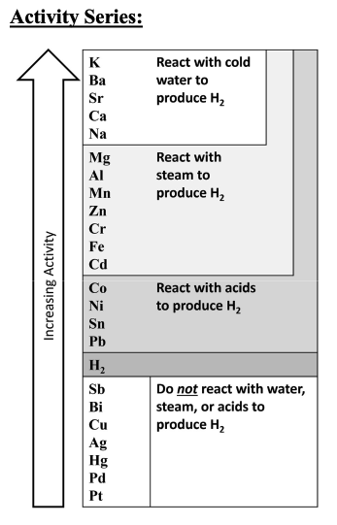
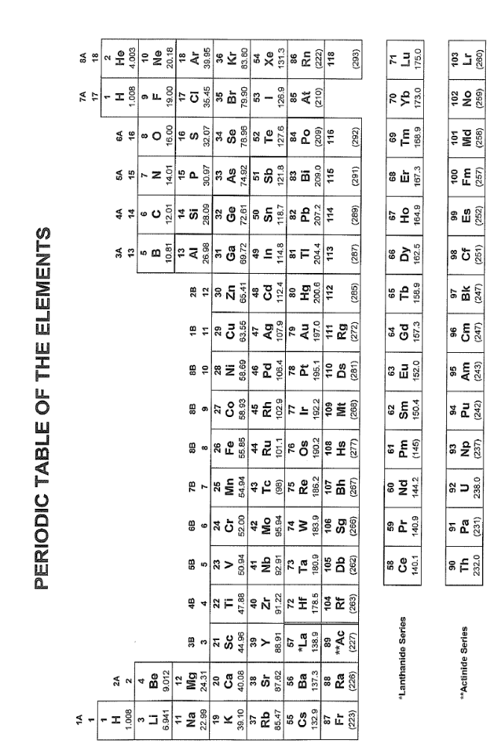

- Which of the following is correctly ordered by increasing atomic radius?

  - N^{3–} < O^{2–} < F–
  - Br < Cl < F
  - Rb⁺ < Kr < Br–
  - P < S < Cl

- Classify the chemical reaction below:
3 H₂ (g) + N₂ (g) → 2 NH₃ (ℓ)

- Decomposition reaction
- Combination reaction
- Single displacement reaction
- Double displacement reaction

- An acid base neutralization reaction is considered a

  - Decomposition reaction.
  - Combination reaction.
  - Single displacement reaction.
  - Double displacement reaction.

- What products are formed by the combustion of octane, C₈H₁₈, in the presence of oxygen? Assume complete combustion.

- Water
- Carbon dioxide
- Water and carbon dioxide
- Water, carbon dioxide, and hydrogen gas

- An iron bar is submerged in sulfuric acid. Does a reaction take place, and if so, what are the products?

- A reaction does not occur
- A reaction occurs; the products are hydrogen gas and iron ions
- A reaction occurs; the products are oxygen gas and iron ions
- A reaction occurs; the product is hydrogen gas

- An tin bar is submerged in a solution of aluminum nitrate. Does a reaction take place, and if so, what are the products?

- A reaction does not take place
- A reaction occurs; the products are tin ions and solid aluminum metal
- A reaction occurs; the products are solid tin and solid aluminum metal
- A reaction occurs and the products are tin and aluminum ions

- Consider the reaction between nitric acid and potassium hydroxide. What ions spectate?

- Potassium and hydrogen ions
- Hydroxide and hydrogen ions
- All ions spectate (no reaction occurs)
- Potassium and nitrate ions

- You mix aqueous sodium sulfide and copper (I) nitrate in the laboratory. Does a reaction take place, and if so, what is the identity of the precipitate?

- A reaction does not take place
- A precipitate of sodium nitrate forms
- A precipitate of copper (I) sulfide forms
- A precipitate of sodium copperide forms
- You mix aqueous potassium perchlorate and ammonium fluoride in the laboratory. Does a reaction take place, and if so, what is the identity of the precipitate?

- A reaction does not take place
- A precipitate of ammonium perchlorate
- A precipitate of potassium fluoride
- A precipitate of potassium ammonide

- Which of the following is a strong acid?

- Hydrofluoric acid
- Perchloric acid
- Carbonic acid
- Phosphoric acid

- Potassium sulfate dissolves in water. What ions are formed?

- K⁺ and S²⁻
- K⁺ and SO₃²⁻
- K⁺ and SO₄²⁻
- P⁺ and SO₄²⁻

- Identify the net ionic equation when aqueous solutions of potassium chloride and sodium hydroxide are mixed.

  - K⁺ (aq) + OH⁻ (aq) → KOH (s)
  - Na⁺ (aq) + OH⁻ (aq) → NaOH (s)
  - Na⁺ (aq) + Cl⁻ (aq) → NaCl (aq)
  - There is no net ionic equation because a reaction does not take place.

- How many grams of sulfuric acid are in 50.0 mL of 0.0100 M sulfuric acid?

- 2.31 grams
- 1.28 grams
- 0.149 grams
- 0.0490 grams

- A 20.0 mL sucrose (C₁₂H₂₂O₁₁, 342.30 g/mol) solution is made using 2.23 g of sucrose. What is the molarity of the solution?

  - $3.26×{10}^{-4}$ M
  - 0.112 M
  - 0.326 M
  - 0.619 M

- Balance the following reaction:
K₂O (aq) + Al(NO₃)₃ (aq) → Al₂O₃ (s) + KNO₃ (aq)
What is the coefficient of aluminum oxide?
- 1
- 2
- 3
- 6

- Balance the following reaction:
N₂ (g) + H₂O (g) → N₂O₄ (g) + N₂H₄ (g)
How many atoms of oxygen are on the reactant side of the balanced reaction?
  - 1
  - 2
  - 3
  - 4

- What is the percent composition of phosphorus in phosphorus pentachloride?

  - 14.87%
  - 46.63%
  - 53.37%
  - 85.13%

- In a 10.00 g sample of N₂O₄ (92.02 g/mol), how many grams of nitrogen are in the sample?

  - 1.52 g
  - 1.74 g
  - 3.05 g
  - 6.95 g

- Elemental boron (white) and elemental chlorine (gray) combine to form boron trichloride according to the unbalanced chemical reaction:
B (s) + Cl₂ (g) → BCl₃ (g)
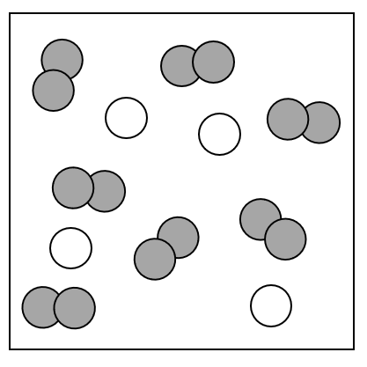
If boron and chlorine are mixed according to the figure, how much of the excess reactant is leftover?

  - 1 atom of B
  - 1 molecule of Cl₂
  - 2 atoms of B
  - 2 molecules of Cl₂

- Using the same figure, what is the theoretical yield of BCl₃?

  - 2 molecules of BCl₃
  - 3 molecules of BCl₃
  - 4 molecules of BCl₃
  - 5 molecules of BCl₃

- The average household in Colorado consumes approximately 163 kg of methane (CH₄, 16.05 g/mol). Given the balanced chemical equation, how many moles of oxygen is needed to combust 163 kg of methane?
CH₄ (g) + 2 O₂ (g) → CO₂ (g) + 2 H₂O (g)

  - 10.2 mol O₂
  - 20.3 mol O₂
  - $1.02×{10}^{4}$ mol O₂
  - $2.03×{10}^{4}$ mol O₂

- If 12.0 moles of nitrogen reacts with 30.0 moles of hydrogen to make ammonia according to the balanced chemical equation, what is the limiting reactant and how much of the excess reactant remains?
$$N_{2} (g) + 3 H_{2} (g) → 2 {NH}_{3} (l)$$

  - H₂ is limiting and 10.0 moles of N₂ is leftover
  - H₂ is limiting and 2.0 moles of N₂ is leftover
  - N₂ is limiting and 18.0 moles of H₂ is leftover
  - N₂ is limiting and 6.0 moles of H₂ is leftover

- If 150.0 g of copper (II) oxide (79.55 g/mol) is consumed by excess ammonia according to the following balanced chemical reaction, what is the theoretical yield of nitrogen in grams?
2 NH₃ (g) + 3 CuO (s) → 3 Cu (s) + N₂ (g) + 3 H₂O ($l$)

  - 17.61 g
  - 21.44 g
  - 34.02 g
  - 119.8 g

- If 35.5 g of potassium chlorate (122.55 g/mol) decomposes and the reaction yield is 83.5%, what is the expected actual yield of oxygen?
2 KClO₃ (s) → 2 KCl (s) + 3 O₂ (g)

  - 11.6 g
  - 13.9 g
  - 18.0 g
  - 21.6 g

- Ellie and Riley decide to go into business producing cinnamaldehyde (C₉H₈O, 132.17 g/mol) to sell to gum manufacturers so they can pay for more dog treats. They use the following balanced reaction to produce the cinnamaldehyde:
C₇H₆O + C₂H₄O → C₉H₈O + H₂O
If they react 100.0 g of C₇H₆O (106.13 g/mol) with excess C₂H₄O (44.06 g/mol) and produce 100.0 g of cinnamaldehyde, what is their percent yield?

  - 100.0%
  - 80.3%
  - 33.3%
  - 17.0%

